

Church of Scyence

Software Learning JS



October 18, 2023

Church of scyence

https://github.com/churchofscyence

Table of Contents

Introduction 2

Starting Learning JavaScript Application 2

Start the Application with Angular CLI 2

Start the Application with Docker Script 3

Application Guide 4

Navigation Bar 4

User Interface 5

Adding Element to the Array 5

Remove the element from the array 5

Change the arrays to be used 6

References 7

# Introduction

We used the Google Angular framework to build a Learning JavaScript Application. No database is connected to this application, so any code you write to the text box will not be persistent. This application is meant to be used at all skill levels, from high school to college. This application can be used to practice the JavaScript language. Users using this application are encouraged to write their tutorial to understand the language better. There will be no tutorial provided with this application. To start this application, use the Docker Script or Angular CLI. The student must install Angular CLI and NodeJS on the command line to start the application with the Angular CLI.  It is recommended that the user install an editor such as Microsoft Visual Studio Code or IntelliJ Jet Brains WebStorn. To use the Docker Script, the user must install the Docker Desktop.

# Starting Learning JavaScript Application

## Start the Application with Angular CLI

The first step is to install NodeJS on the computer. Install instructions are in the Reference section of the Software Learning JS document on the Church of Scynce GitHub in the Script Repository. The next step is to populate the node modules folder by running the npm install command, the Node Package Manager (NPM), from the Windows Command Line or Mac Terminal Windows. The first step is to populate the node modules folder by running the npm install command, the Node Package Manager (NPM), from the Windows Command Line or Mac Terminal Windows. Node Package Manager reads the angular JSON file to download all the necessary libraries.

The 'ng service' command builds, deploys, serves, and watches your angular code changes. Angular CLI runs Webpack to build and bundle all JavaScript and CSS code. In turn, Webpack calls the TypeScript loaders, which fetches all .ts files in the Angular project and then transpiles them to JavaScript, i.e., to a .js file, which browsers can understand.

## Start the Application with Docker Script

First, the user must build a Docker image. A Docker image is a read-only template that contains instructions for creating a container that can run on the Docker platform. It provides a convenient way to package up applications and preconfigured server environments, which you can use for pre-use or share publicly with other Docker users. Docker images are also the starting point for anyone using Docker for the first time. From the command line, run the f, the following command.

$ docker build . -t sofware-learning-js

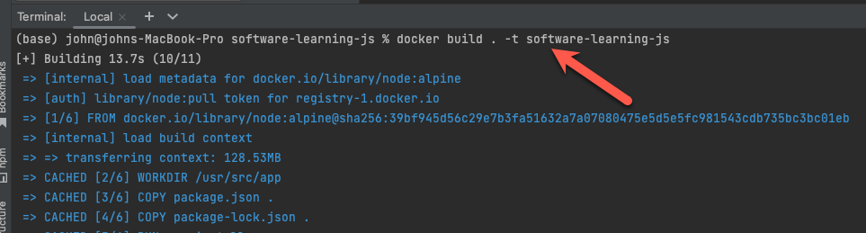

In the Docker Desktop, you can see that the image was created. You can see the size of the picture. It should be approximately one gigabyte. The name of the image is software-learning-js. The users can also check the creation time to verify that the idea was completed successfully.

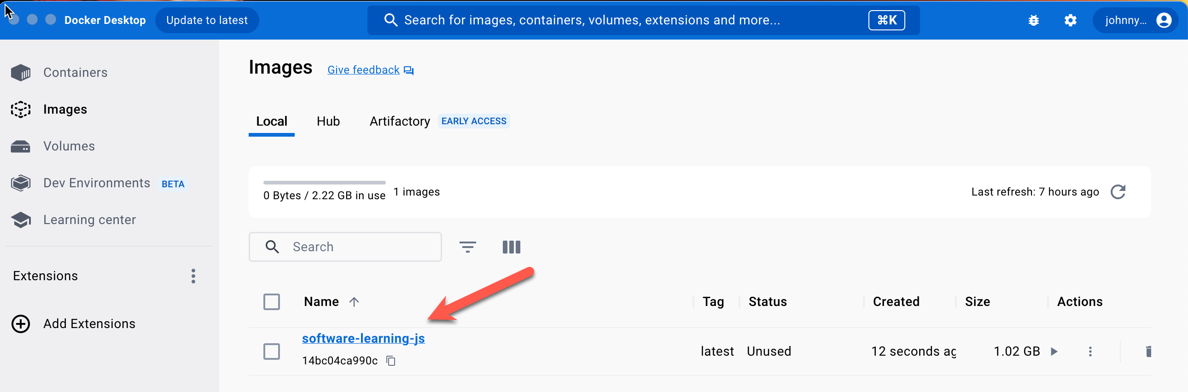

The Next step is to create a container from the image. A Docker container image is a lightweight, standalone, executable package of software that includes everything needed to run an application: code, runtime, system tools, system libraries, and settings.

$ docker runDocker200:4200 software-learning-js

You can go into Docker Desktop to access the container. After creating the container, the user can open the webpage browser and navigate to the following URL.

http://localhost:4200/

# Application Guide

## Navigation Bar

You can select the part of the JavaScript language you want to practice from the navigation panel.  The user can choose an **Array,** one of the most commonly used data types. It stores multiple values and elements in one variable. These values can be of any data type. You can keep a string, number, boolean, and other data types in one variable. The to the array is Strings. A JavaScript **String** stores a series of characters like "John Doe ."A string can be any text inside double or single quotes. The last item in the navigation bar is **Regular Expression,** a sequence of [characters](https://en.wikipedia.org/wiki/Character_(computing)) that specifies a [match pattern](https://en.wikipedia.org/wiki/Pattern_matching) in [text](https://en.wikipedia.org/wiki/String_(computer_science)).

## Initialize Arrays Interface

### Adding Element to the Array

To add an element to the first yo, you must choose by selecting the array from the Choose Table Drop Down Box. Next, type in the Netow Element Text Box the Element. For Example, if I want to add Strawberries to the fruits array, I would select Fruits from the **Choose Table**. Then, type Strawberry in the **New Element Text Box**. Finally, click the **Add Button** below the Add Element Form.

The user will see **Strawberry** appear in the last element in the **Fruits array**.

### Remove the element from the array

The user deletes an element from an array by clicking the **Remove Button** in the **Action Column** table. For Example, if the user wants to remove the third element, Apple, from the table, click the Remove Button in the same row as the Apple row.

After clicking the Remove Button, the user will see the Apple disappear from the third row.

### Change the arrays to be used

If the users want to use a different array in the Code Editor, you can select which in the Select Array Form. For Example, the users wish to use the Unique Integer instead of the Peoples array. In the Choose Table Drop drop-down box, select Peoples Array. Then select Unique Integer in the Array List drop-down box. Finally, click the Select Button.

After clicking the Select Button, you can see the two arrays the user can use in the Code Editor in Fruits and Unique Integer.

## Code Editor Interface

### Using the Code Editor

### Array Result Types

***Result Array*** - This method type returns makes a new array which must be assigned to a variable.

***Result Boolean*** - This does not array but method type returns true or false value. Click on the Show Button on the Final Result Form to see the result.

***Result Number*** - This method type returns index number of the array.

***Result String*** - This method type return a string.

***Change Array*** - This method type changes the existing array.

***Empty Array*** -

# References

* [How to Install Node.js on Window 10](https://www.youtube.com/watch?v=__7eOCxJyow)
* [How to install Nodejs on Mac [Any version & Easy method]](https://www.youtube.com/watch?v=SwUKKCS3r3c)
* [Running a project with ng serve](https://www.youtube.com/watch?v=-w-RfHcLt5U)
* [How To Install Docker on Windows 11](https://www.youtube.com/watch?v=WDEdRmTCSs8)
* [Docker Desktop for macOS Setup and Tips](https://www.youtube.com/watch?v=gcacQ29AjOo)
* [JavaScript Tutorial for Beginners: Learn JavaScript in 1 Hour](JavaScript%20Thttps:/www.youtube.com/watch?v=W6NZfCO5SIk)
* [Regular Expressions (RgeEx) Tutorial -Net Ninja](https://www.youtube.com/playlist?list=PL4cUxeGkcC9g6m_6Sld9Q4jzqdqHd2HiD)